SENDGRID INTEGRATION WITH PYTHON

|  |  |
| --- | --- |
| Date | 05 NOV 2022 |
| Team ID | PNT2022TMID06816 |
| Project Name | NUTRITION ASSISTANT  APPLICATION |

**STEP 1:**

REQUIREMENTS:

Python 2.6, 2.7, 3.4 or 3.5.

STEP 2:

Create an API key

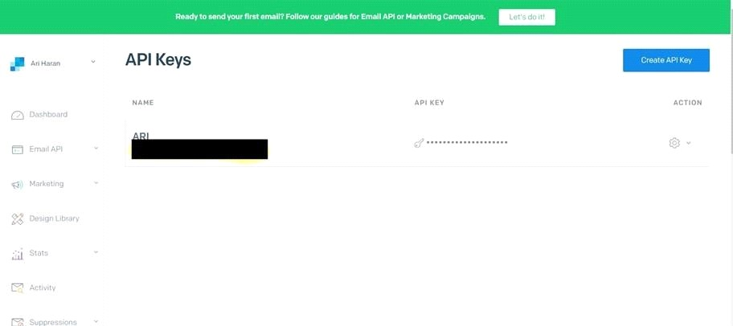

STEP 3:

INSTALL

PAKAGE: > pip installsendgrid

SETP 4:

SEND EMAIL

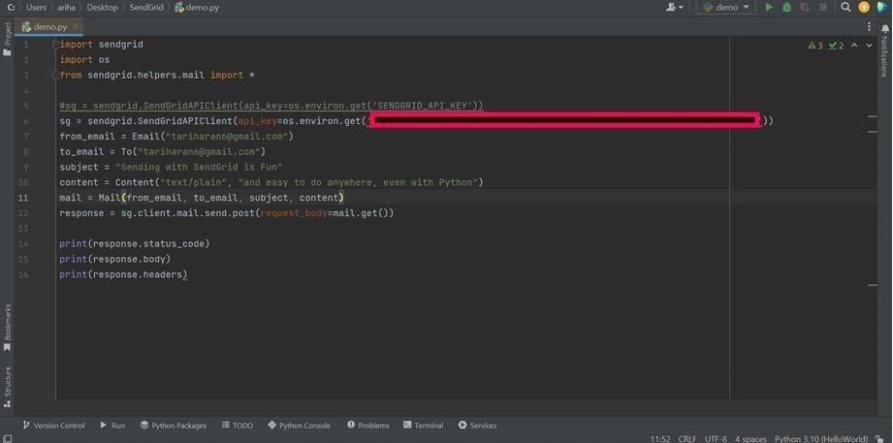

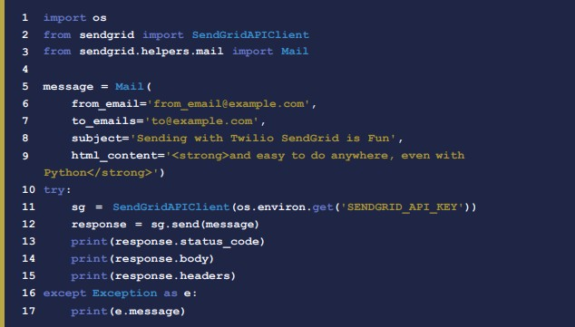SENDGRID PYTHON CODE :

HTTP CLIENT PROGRAM



